Ideation Phase
Brainstorm & Idea Prioritization
Date | 26-09-26
Team ID | 23KD1A4230
Project Name | Metro Ticket Generating System in ServiceNow
Maximum Marks | 4 Marks

Problem Identification
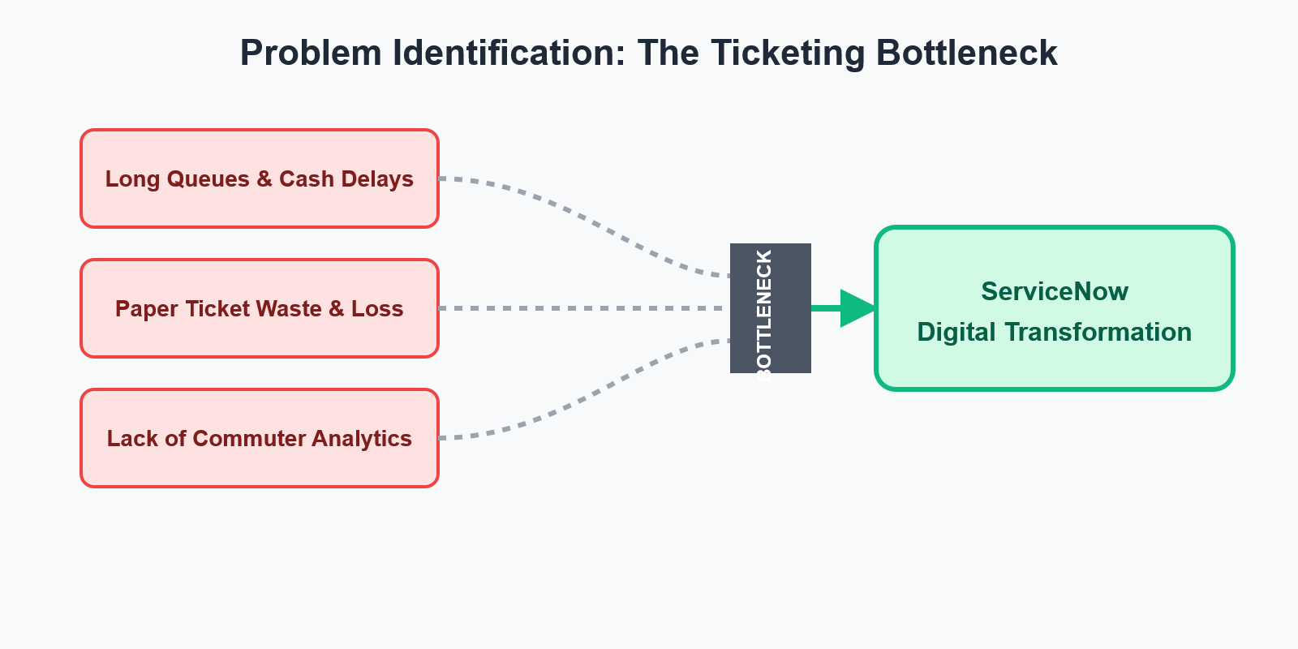
- Long Queues: Traditional ticket counters cause heavy delays during peak hours.
- High Costs: Manual, cash-based transactions require too much staff time and effort.
- Paper Waste: Physical tickets are easily lost by passengers and hurt sustainability goals.
- No Analytics: Offline ticketing prevents the metro from tracking passenger travel trends.
Brainstormed Features
- Digital Booking Form: A simple online catalog for users to select their source and destination.
- Automated Fares: Scripts that instantly calculate ticket prices based on the user's choices.
- QR E-Tickets: Scannable, paperless digital tickets generated right on the user's screen.
- Backend Automation: System workflows that save and manage booking data automatically.
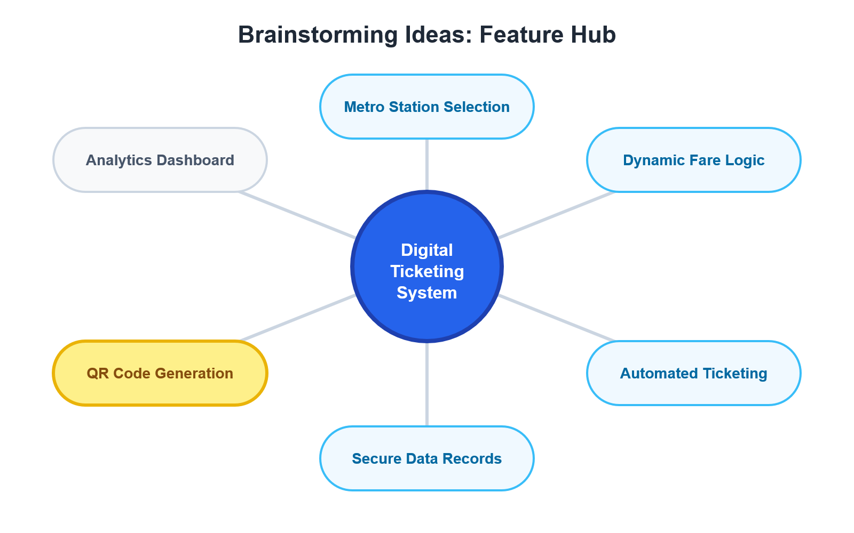
Implementation Map
